HABIBATA Y. DAUDI

DIGITAL HEALTH EXAM

DATA ANALYSIS USING R PROGRAMMING – THE INCIDENCE OF HYPERTENSION ACROSS TEN REGIONS IN GHANA IN AUGUST 2023.

DISCLAIMER: DATA USED IN THIS PROJECT WAS SELF-GENERATED AND THUS DOES NOT TRULY REPRESENT A REAL-LIFE SITUATION.

TOTAL NUMBER OF ENTRIES - 999

1. summary(hd$gender=='F')

OUTPUT

|  |
| --- |
| summary(hd$gender=='F')  Mode FALSE TRUE  logical 491 508 |
|  |
| |  | | --- | |  | |

1. summary(hd$age)

OUTPUT

summary(hd$age)

Min. 1st Qu. Median Mean

20.00 35.00 50.00 50.24

3rd Qu. Max.

65.00 80.00

1. summary(hd$hypertension=='yes')

OUTPUT

> summary(hd$hypertension=='yes')

Mode FALSE TRUE

logical 530 469

1. ggplot(hd,aes(x=age)) + geom_histogram(binwidth = 2, fill = "blue", color ="red",

alpha =0.8 )+ labs (title = "Age Distribution",

x= "Age", y = "Frequency")

OUTPUT

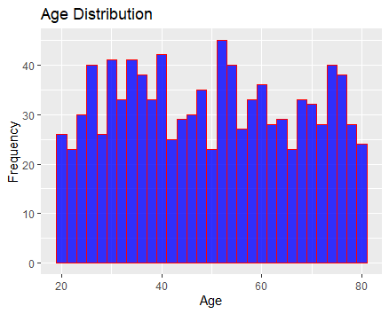

1. ggplot(hd, aes(x=gender, y= age, fill=gender)) + geom_boxplot() +labs(title = "Age Distribution by Gender", x= "gender", y= "age") + theme_minimal()

OUTPUT

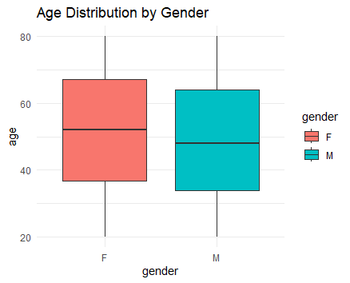

1. ggplot(hd, aes (x=factor(education.level), fill=factor(education.level))) +geom_bar()+

labs(title = "Education Distribution", x="education level", y="count")+

theme_minimal()

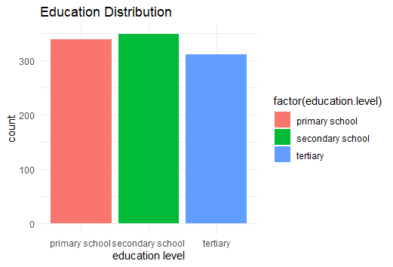

1. ggplot(hd, aes (x=factor(region), fill=factor(region))) +geom_bar()+

labs(title = "Regions", x="region", y="count")+

theme_minimal()

OUTPUT

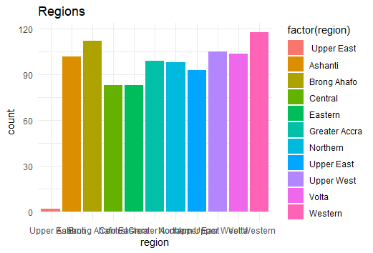

1. ggplot(hd, aes(x= age, y=bmi)) +geom_line()+

labs(title = "Line Graph", x="age", y="bmi")

OUTPUT

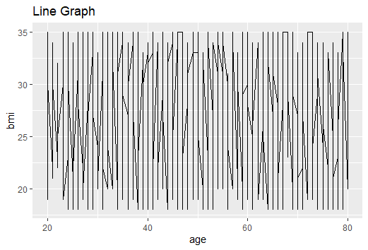

1. ggplot(hd, aes(x= age, y=bmi)) +geom_point()+

labs(title = "Line Graph", x="age", y="bmi")

OUTPUT

